**Cranberry – 7435 C**

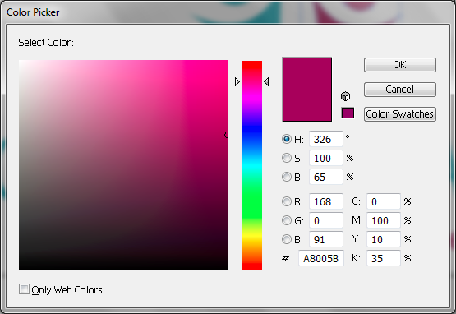

**Blue – PANTONE 7467 C**

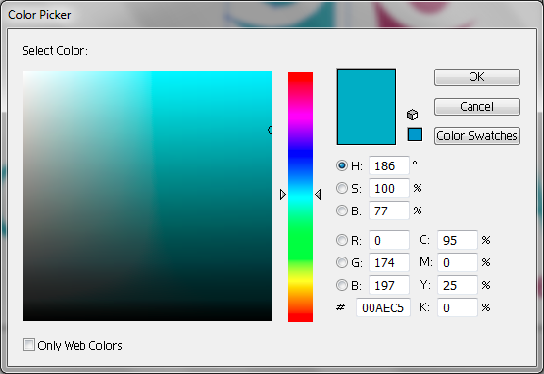

**Cool Gray – PANTONE Cool Gray 10 C**

